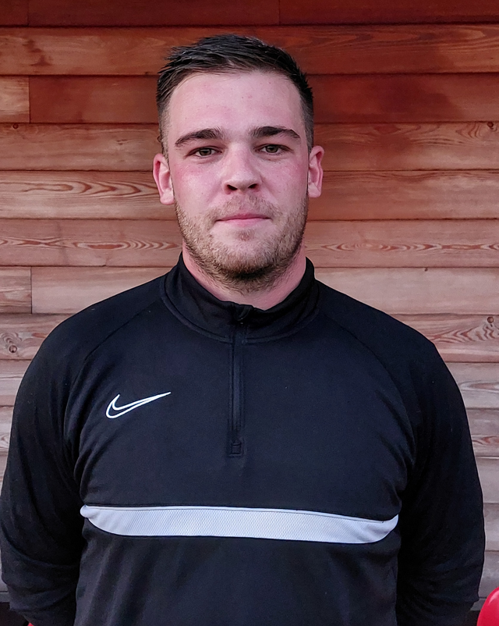 | JORDAN DUNNING – GOALKEEPER  An excellent shot-stopper and commanding presence in the box, this is Jordan’s third year with the club after spells with Tytherington Rocks and Bristol Manor Farm.
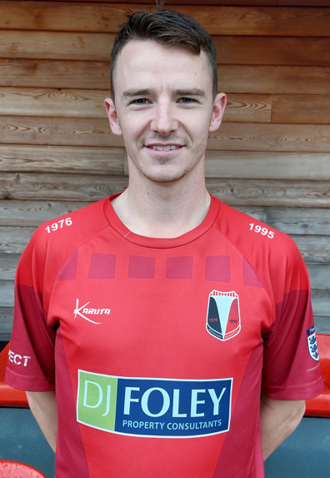 | PETER IRELAND – FULL BACK  Nicest lad in the club, Pete nonetheless puts it all in on the pitch, though for all his endeavour, a goal still eludes him.
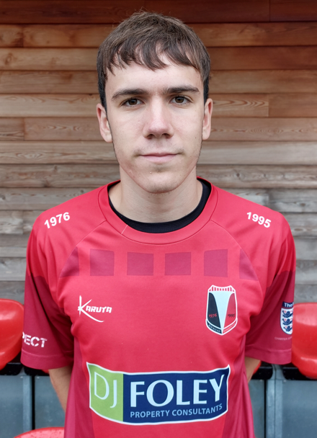 | TASMAN ROOK – FULL BACK  New signing who joined the club in the second half of the 2022/23 season from Chippenham Town, Tas will be hoping for an injury free campaign this year.
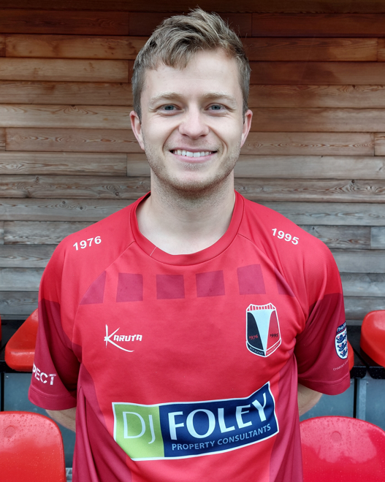 | MARCUS WILLIAMS – FULL BACK – VICE CAPTAIN  Club stalwart, after starting at Under 6’s with Rockleaze Marcus equally adept at fullback or midfield.
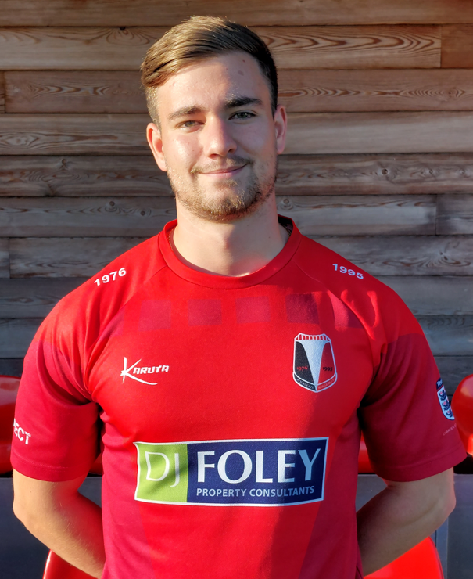 | AIDAN HALL – FULL BACK  The Ice-Man is a solid full-back with a penchant for gold chains and fake tan. Dreams to appear on Love Island one day.
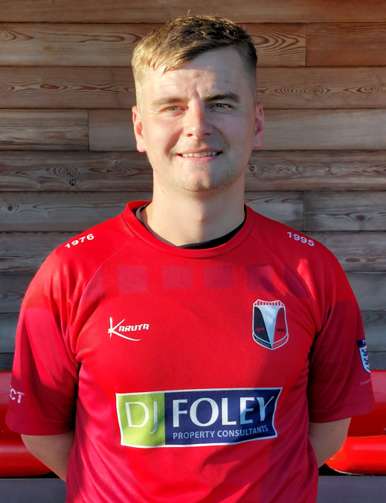 | JOSHUA GROTZKE – FULL BACK  Josh is a versatile defender with years of experience in the County League. Voted Chairman’s Player of the Year 2022/23.
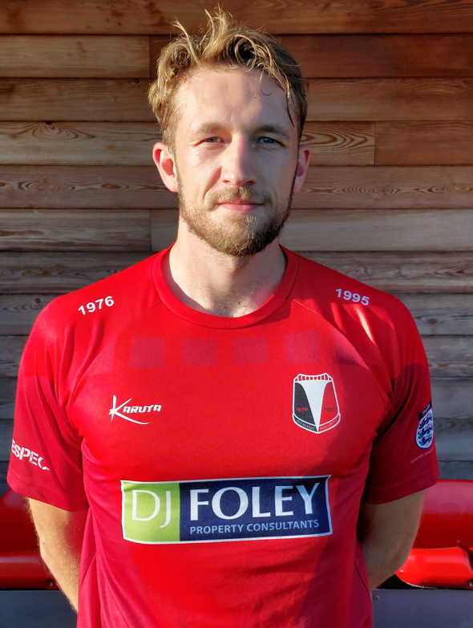 | JORDAN BUCKETT – CENTRE BACK – CAPTAIN  A natural leader on and off the pitch, Jordan has matured well into the captaincy, leading by example through consistently putting in strong performances.
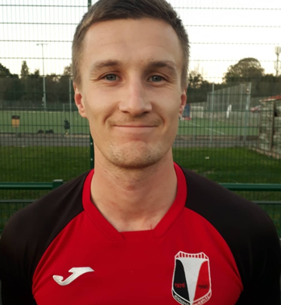 | MICHAEL PERHAM – CENTRE BACK  Rarely seen at training, and never at preseason, Mike is nonetheless class. Occasionally chips in with goals (at both ends).
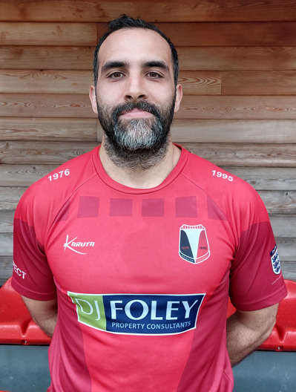 | ZAKI ELGAHMI – CENTRE BACK  Cultured and experienced centre back, Zaki brings an air of calm to matches. Recently appointed assistant manager for the 2023/24 season.
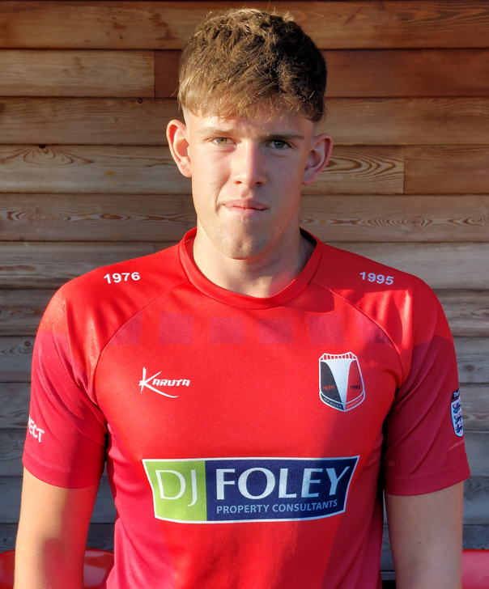 | MAX HODGSON – CENTRE BACK  New signing Max is a talented ball playing centre back who has earned his place in the squad following a number of strong performances during preseason. At 6’4”, 17 year old Max is an exciting prospect.
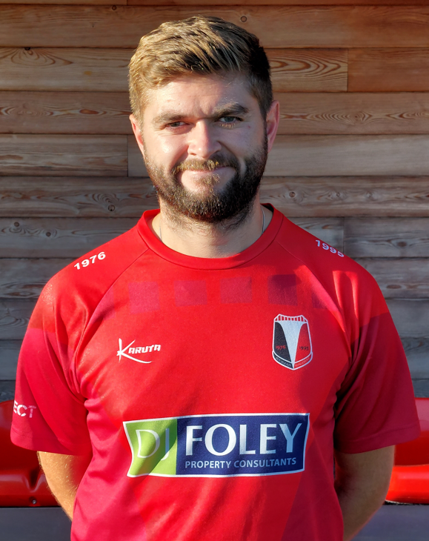 | OLIVER WOOLLAND – CENTRE BACK  Ollie currently holds the record of ‘most spells with the Club’ jointly with Jay Moore. A versatile player, former Southampton academy player, Ollie can play anywhere along the back or in midfield.
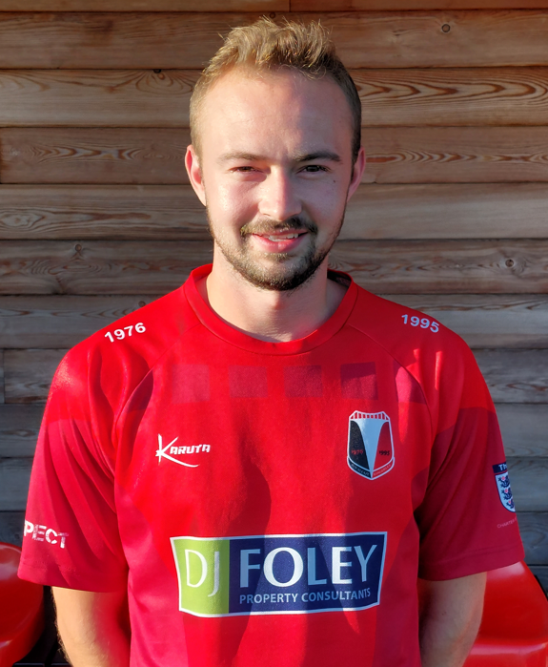 | JOSHUA BUTT - MIDFIELD  Brother of Fraser, new addition to the squad for 2023/24, Josh is a talented box-to-box midfielder. Cos-plays as Tintin in his spare time.
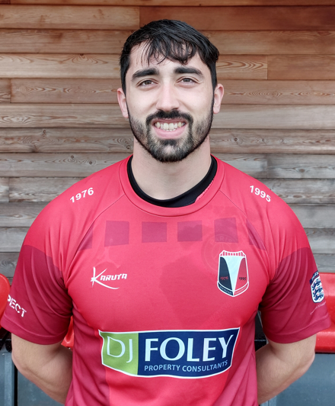 | BRANDON BOONTAM – MIDFIELD  When you’re that good, you can afford to be a little bit lazy… Bran is an outstanding player, who from time-to-time gets his freekicks on target.
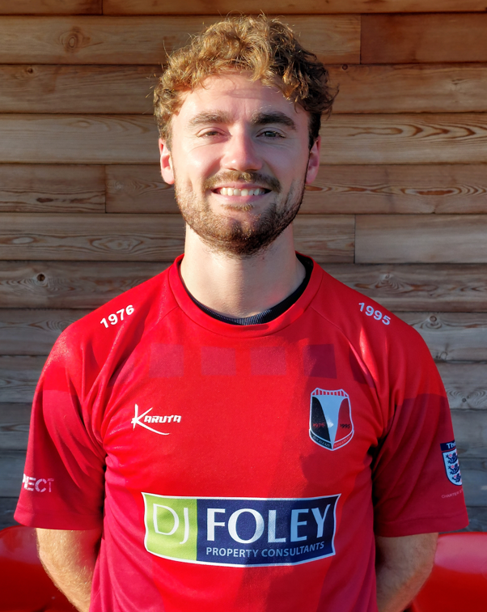 | DREW SAWDON – MIDFIELD  Hard hitting midfielder hailing from the North, Drew has been promoted from our Reserves after a number of excellent performances at the end of the 2022/23 season.
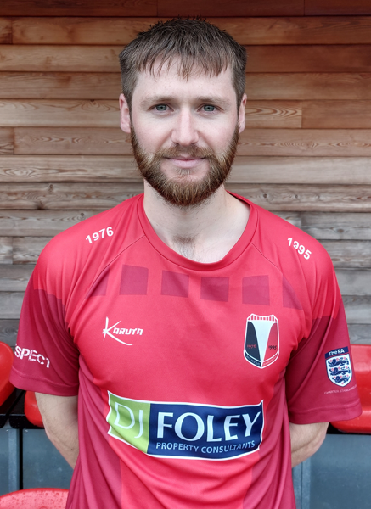 | SAMUEL BAILEY – MIDFIELD  Silent assassin, bandit-Bailey is a classy midfielder who both links up play and scores goals through his late runs into the box.
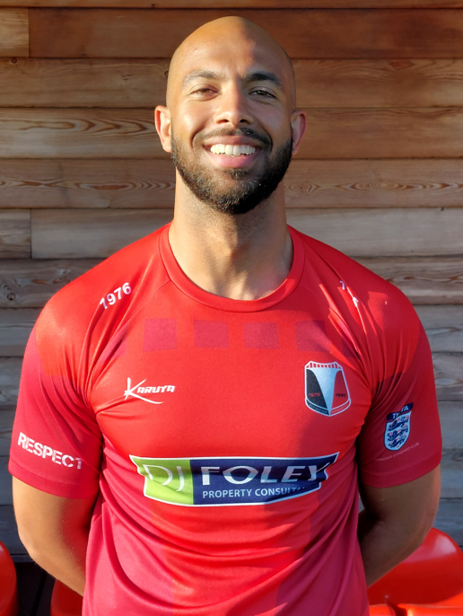 | AHMED HUSSEIN – MIDFIELD  New recruit who joins the club from SCBC Stockholm. Ahmed has impressed during preseason with great technical ability and vision.
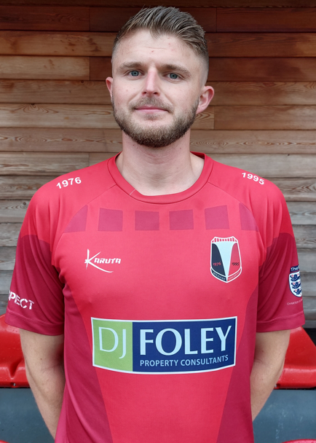 | JONATHAN WEBB – MIDFIELD  New signing Jon joins us from Mangotsfield, and has put in a number of strong performances during pre-season, whilst also chipping in with a few goals.
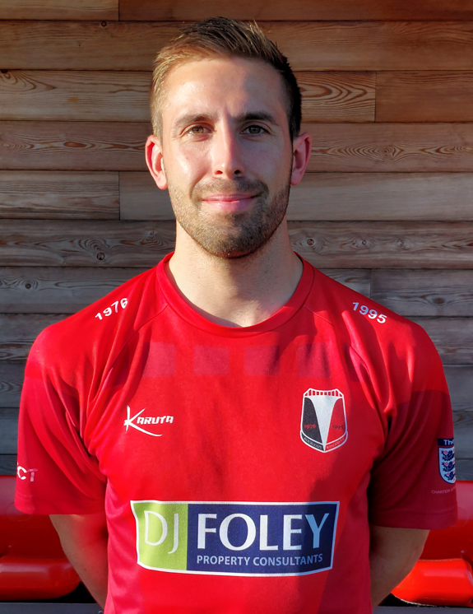 | NICHOLAS JONES – FORWARD  Now back for his second spell with the club after two successful seasons with Cribbs, Nick brings pace, experience and a winning mentality to the side.
HENRY JONES – FORWARD
Not known for his defensive credentials, Henry compensates for this with piercing runs, quick feet and an excellent delivery. Loves a tap-in too.
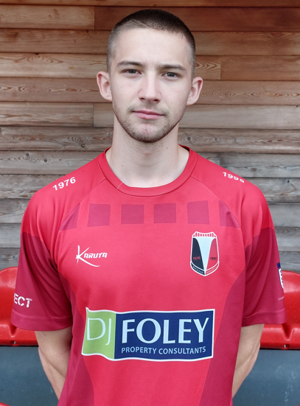 | TATE SHAW – FORWARD  Tate brings extreme pace to the side, making a strong impression after signing from Patchway Town during the second half of the 2022/23 season.
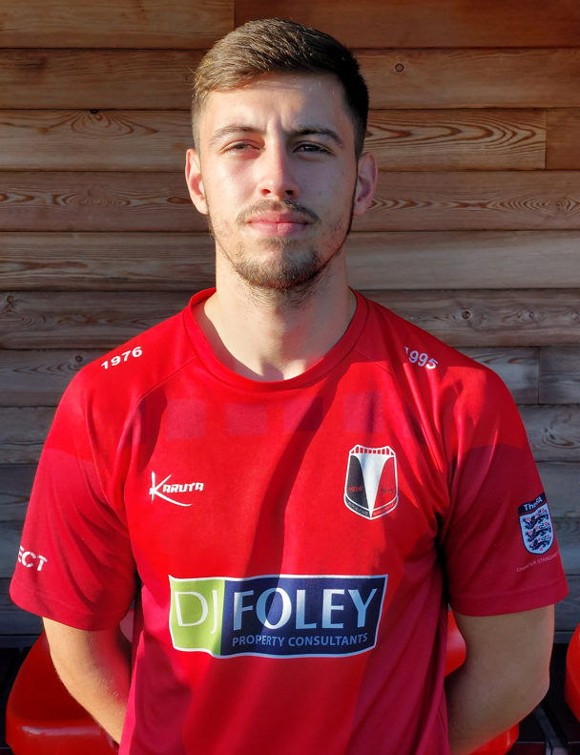 | FRASER BUTT – FORWARD  Former Gloucester City academy player, Fraser is a mercurial talent with an eye for goal, as well as being a set piece specialist.
MATTEO PALI – FORWARD
New recruit Matteo joins the club from Patchway Town, bring trickery and guile with his customary Italian flair.
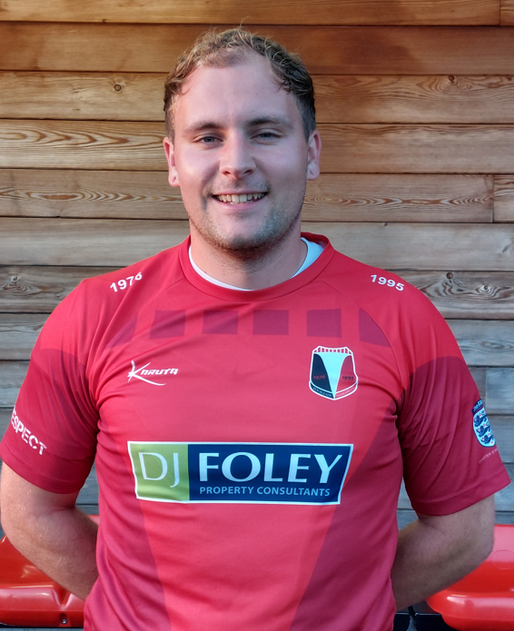 | JORDAN DENT – FORWARD  Despite a string of injuries over the last few seasons, “Barry” Dent is nonetheless a quality forward with an eye for goal. Liability on a night out though.
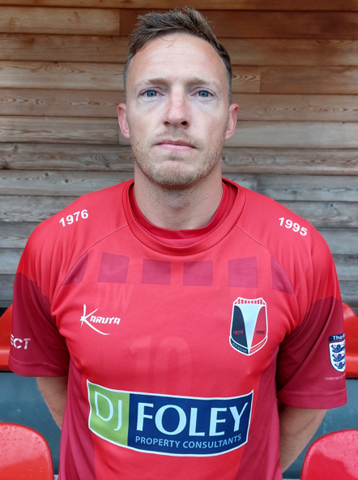 | DANIEL WEBB – FORWARD  Tour and social secretary, Webby is also a Gloucestershire County League veteran, having terrorised opposition with his skill, movement and goals for a number of years.
JENSON BEARD – FORWARD
After a breakthrough season in 2022/23, Jenson will be looking to cement his place in the starting line-up. An excellent pre-season, backed up with goals has not harmed his chances. #UTL
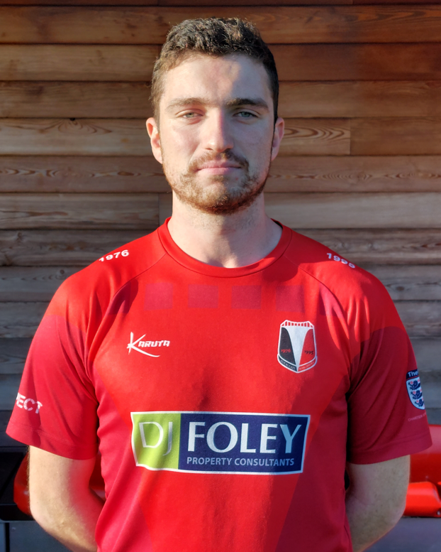 | GEORGE JAMES – FORWARD  Goal machine GJ9 finished the 2022/23 season as the club’s top goal scorer, despite having played the rest of his career at centre back. Loves penalties and tap-ins.
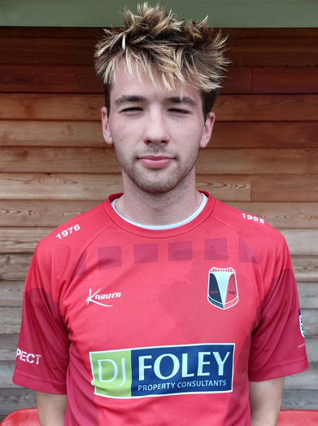 | JAMES GOULDEN – FORWARD  With 9 goals in 5 games over preseason, it’s fair to say new signing James has hit a bit of form. Tall and tricky, backed with a great touch and movement, he’s one to watch.
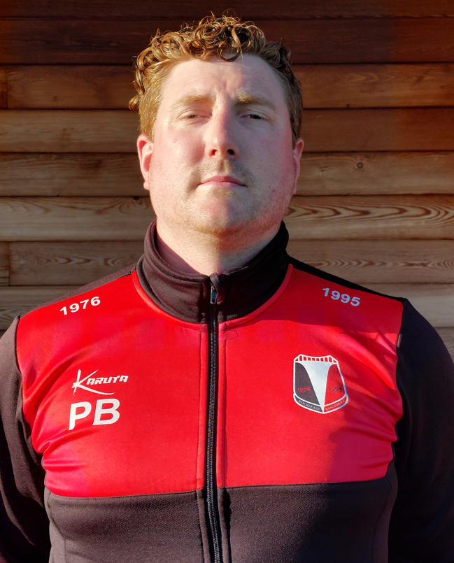 | PETER BRADBURY – MANAGER  Manager and no.2 goalkeeper.
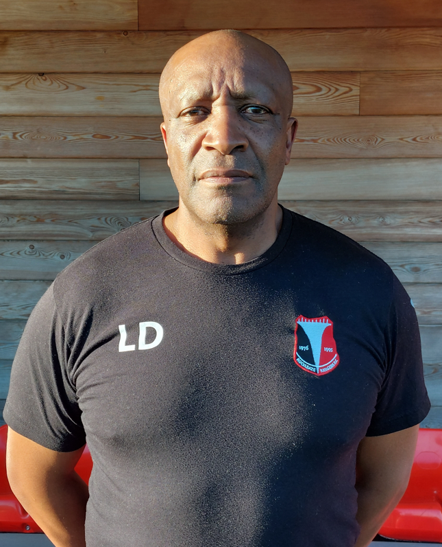 | LEE DOUGLAS – ASSISTANT MANAGER  Long suffering assistant to Bradders, now in their thirteenth season together.
MATTHEW DYER – ASSISTANT MANAGER / PHYSIO
Recent addition to the management team, when not scuttling onto the pitch with the magic sponge, Spanish Matt also prepares pre- and post-match video analysis.

